SQL Modernisation Hack

Database Administering and Monitoring Labs Step-by-step
V4.0

Contents
Migration architecture and Azure components 2
Lab Overview & Background 3
Background 3
LAB 1: Identifying performance issues, their root causes and fixing the problem 4
1. Using DMVs and the Query Store to identify performance bottlenecks. 4
2. Using the Azure Portal to identify performance bottlenecks 10
3. Using Log Analytics with KQL to visualize SQL MI and Database Stats 12

Migration architecture and Azure components

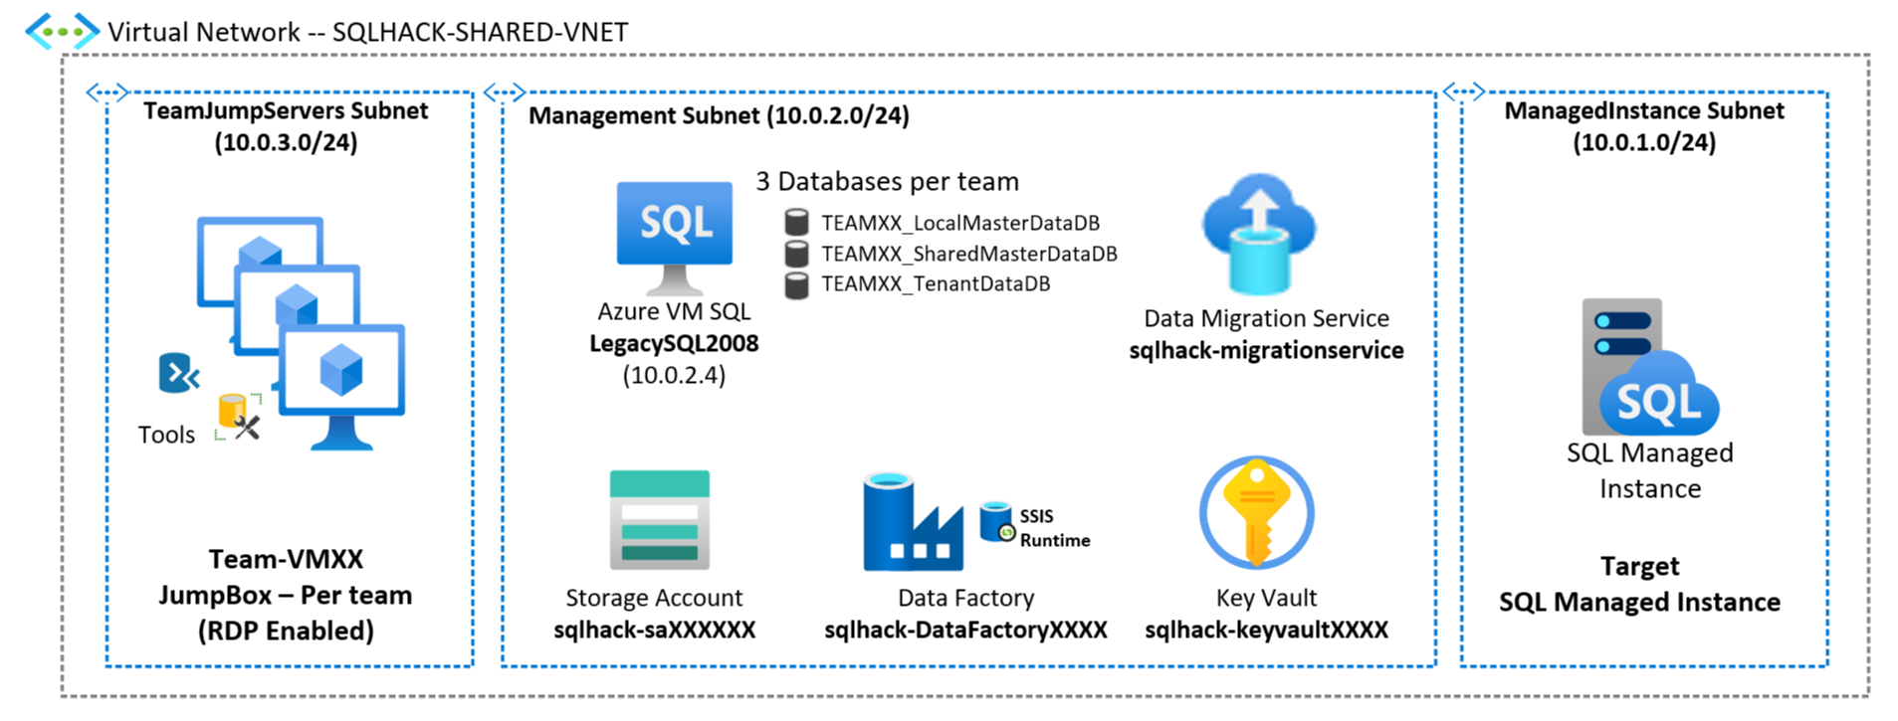
SQLHACK-SHARED-VNET
Single Virtual Network containing all workshop resources
TeamJumpServers Subnet  Each team is assigned a Win10 VM that mimics their company desktop |  | Management Subnet  Several machines and services are already deployed within a dedicated subnet within the Virtual Network |  | ManagedInstance Subnet  The Azure SQL Managed Instance has been deployed into a dedicated Subnet

Lab Overview & Background
In this exercise you will explore how you can monitor and diagnose performance issues with Azure SQL Database Managed Instance using SQL Server Management Studio, DMVs (Dynamic Management Views) and Azure Portal tools.

Background
We have seen that the legacy application is a multi-tenant system with a collection of 3 databases supporting the transactional workload for each customer – these are the 3 databases we have modernised by migrating to the shared Azure SQL Managed Instance.

Apart from the tenant centric transactional databases there are 2 shared databases:
- 2008DW: A centralised Data Warehouse database that combines data from the various tenant transactional databases and is used for aggregated reporting and analytics.
- TenantCRM: A centralised database that is used to manage all customer relationships and order processing.

Recently you have heard complaints from users that the TenantCRM system is running slowly. Recently changes were made to some of the stored procedures in the TenantCRM database and the App dev team believe these are the source of the problem. They’ve asked for your help to track down the performance issues and its root cause.

Let’s follow the steps below to begin to troubleshoot this issue.

The exercises in this lab are conducted against the shared [TenantCRM] database

LAB 1: Identifying performance issues, their root causes and fixing the problem

Using DMVs and the Query Store to identify performance bottlenecks.
Performance issues in SQL Server can be grouped into 1 of 2 high-level categories: Running or Waiting.
Running means a query has been allocated CPU resource and is actively processing but is taking a long time to complete. Waiting means a query is not actively being processed by the CPU but is waiting on another resource (such as memory, disk, network, etc) to pass data in so processing can continue.
Finding the bottleneck will help us determine what category issue we have so we can progress to identifying the root cause. Let’s see how to find the bottleneck using both SSMS and the Azure portal.
Instructions/Narrative | Screenshot | Notes
On your Win10 Team VM open the Azure Portal and navigate to the shared SQL Managed Instance.  Scroll down the Overview screen copy the host name of the Managed Instance and save it somewhere handy. | 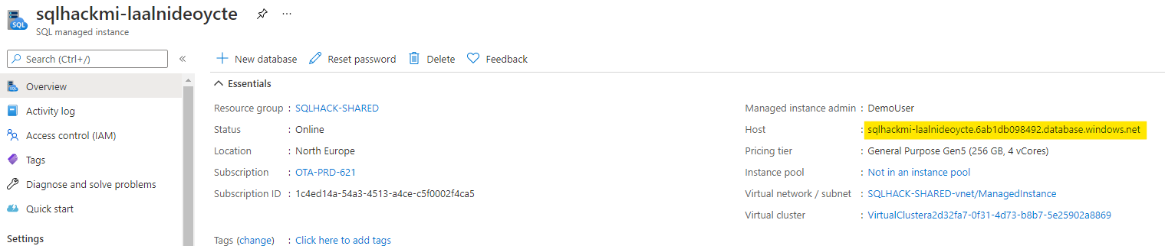
On your Team Win10 VM open Azure Data Studio and Add Connection using these details:  Server: <just copied>  Authentication: SQL Login  Login: DemoUser  Pword: Demo@pass1234567 | 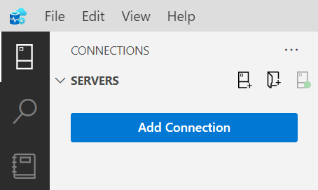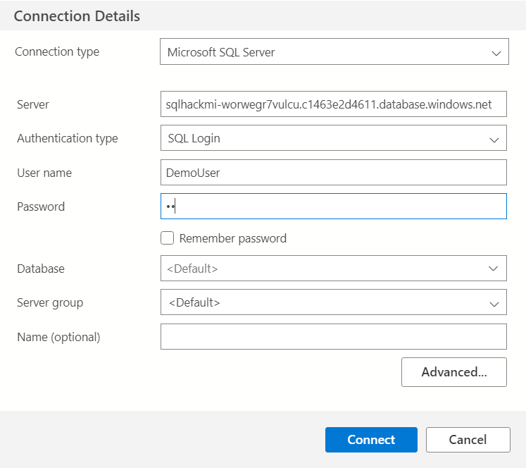

Narrative/Instructions | Screentshot | Notes
Open the SQL script:  C:\_SQLHACK_\LABS\02-Administering_Monitoring\Part_01_Monitoring_Lab_1.sql  Run the PART 1 query 1.  Look at the results and note the [avg_cpu_percent] value is about 70% indicating that this database is consuming a lot of the hosts CPU resources | 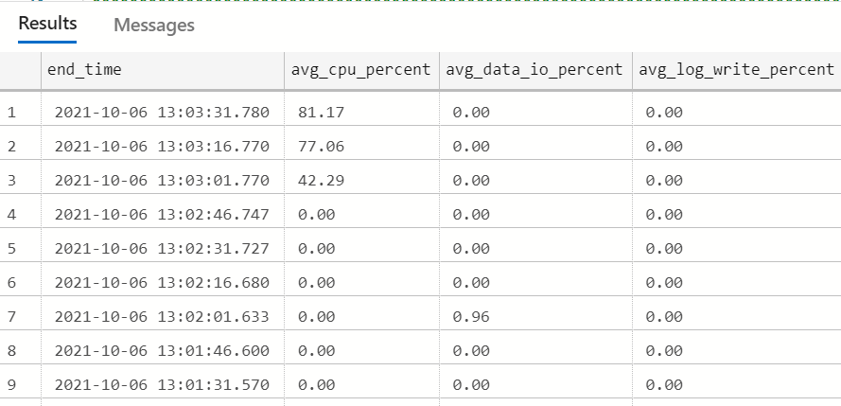 | [sys].[dm_db_resource_stats]  exposes a number of key database performance metrics.  One metric every 15 seconds over the last hour
Narrative/Instructions | Screenshot | Notes
Let’s try now query 2 to visualize graphically the resource consumption.  Execute Query 2 and on the results, activate the Chart view  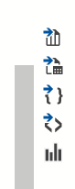  On the Right  Settings  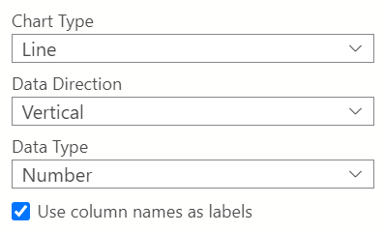 | 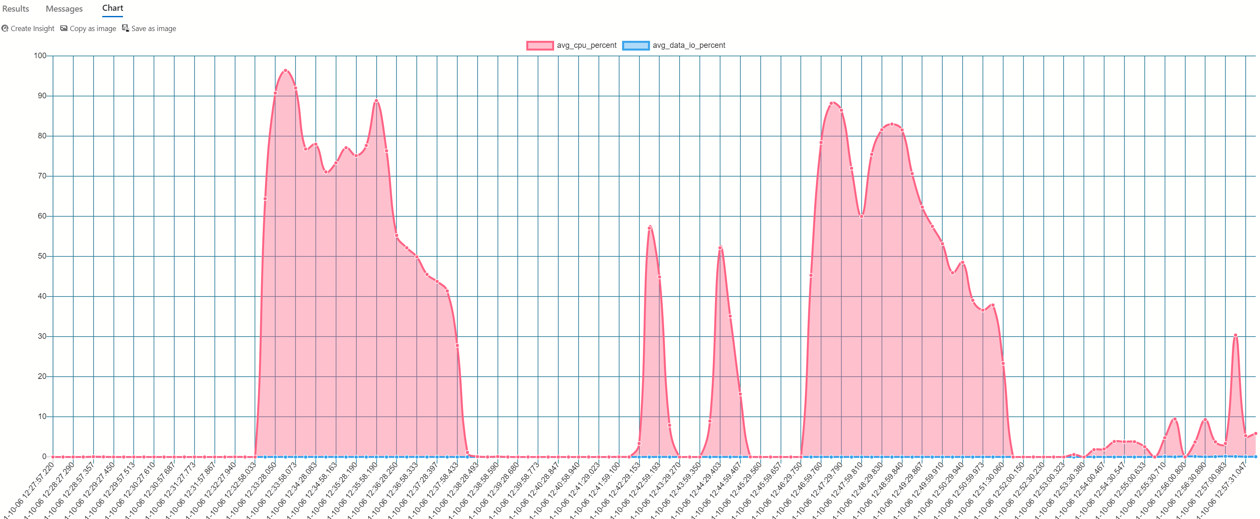 | If more than 1 hour of statistics is needed, use the DMV [sys].[server_resource_stats] up to 14 days

Instructions/Narrative | Screenshot | Notes
Open SQL Server Management Studio using the same details:  Server name: SQL MI  Authentication: SQL Server  Login: DemoUser  Pword: Demo@pass1234567 | 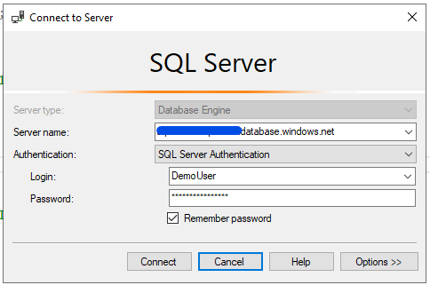
Open the SQL script:  C:\_SQLHACK_\LABS\02-Administering_Monitoring\Part_02_Monitoring_Lab_1.sql  Run the PART 2 query 1.  Identify the most consuming stored procedure based on the total_worker_time (CPU) | 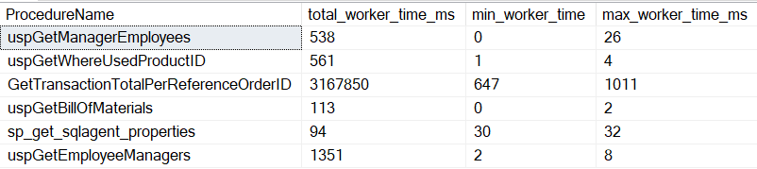
Then to have further details on the most consuming stored procedure  Run the PART 2 query 2, replace the filter clause with the stored procedure name.  What is the issue? How to optimise?  Tip: Have a look to the execution plan | CROSS APPLY and Table-valued Functions  The PART 2 query joins the [sys].[dm_exec_requests] and [sys].[dm_exec_sql_text] DMVs to obtain long running batches and critically their offending SQL.  Note that [dm_exec_sql_text] is actually a table-valued function (TVF) hence the use of the CROSS APPLY as TVFs can't be used in a normal join operation. The CROSS APPLY therefore produces the required inner-join between [dm_exec_requests] and [dm_exec_sql_text].  See APPLY documentation here: Using APPLY | Microsoft Docs and this excellent explanation on MSSQLTips: SQL Server CROSS APPLY and OUTER APPLY (mssqltips.com)
In SSMS expand the [TenantCRM] database then expand Query Store.  Remember that the Query Store collects telemetry data every 15 seconds and persists it for about 1hr.  Double click on Overall Resource Consumption report to open it. | 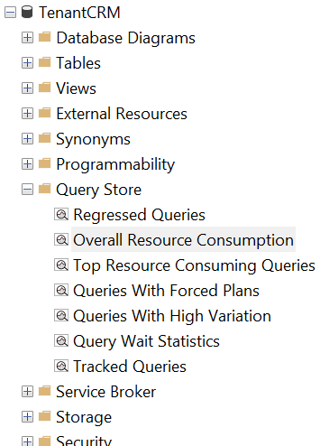

Narrative/Instructions | Screentshot | Notes
For further details CPU Time, double click on the current day bar | 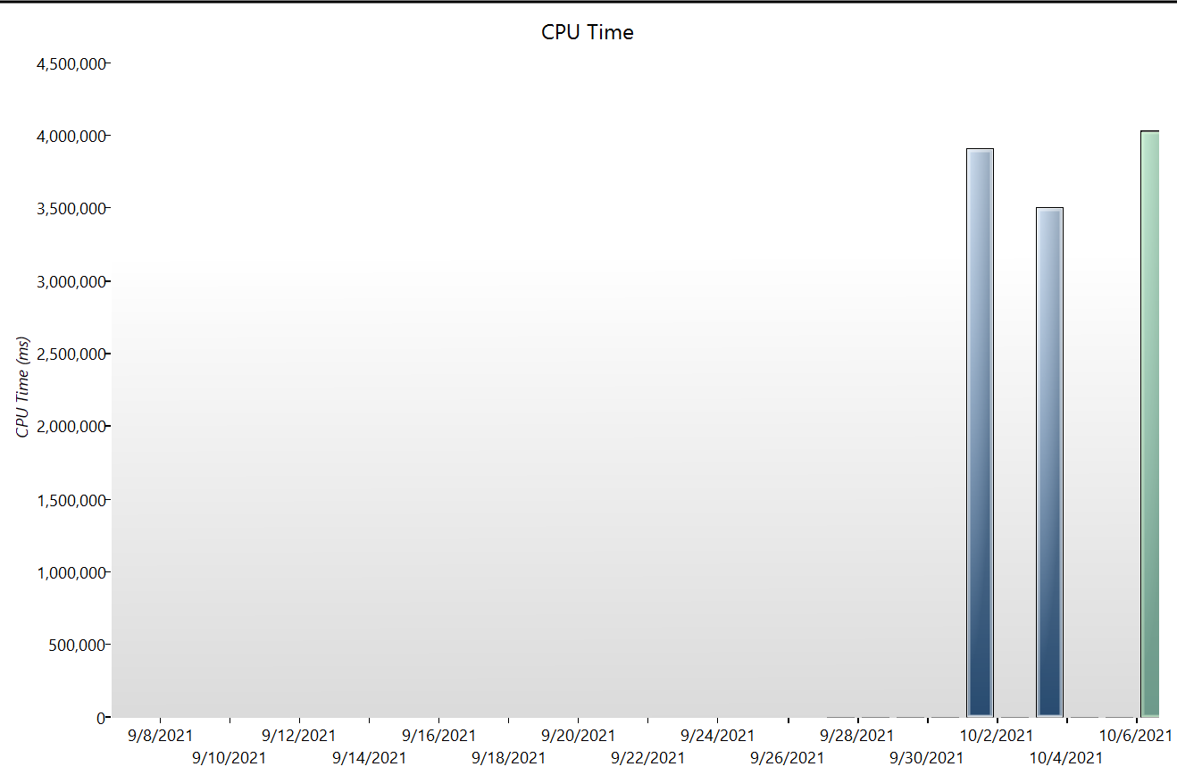
You can identify the top CPU consuming queries.  Click on bars for more details | 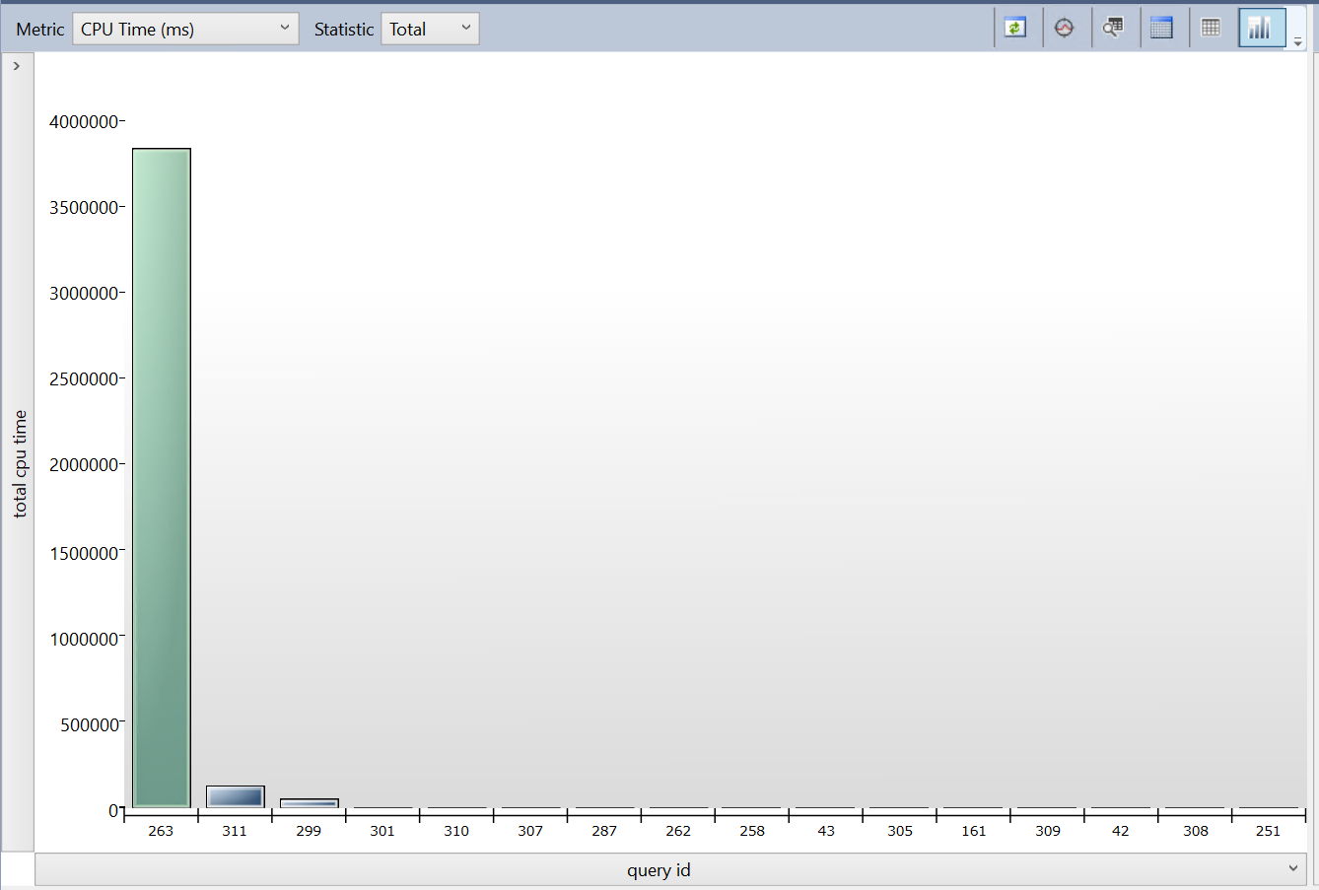

Using the Azure Portal to identify performance bottlenecks
As we are using Azure SQL Managed Instance we can also use the richness of the Azure Portal to help us to troubleshoot performance issues. Let us see how this is done.
Instructions/Narrative | Screenshot | Notes
Open the Azure Portal (portal.azure.com) and open the shared SQL Managed Instance.  Scroll down the Overview screen until you see the performance graph showing CPU utilization.  Toggle the switches next to view CPU consumption over 1 hour, 24 hours and 7 days.  Has the CPU usage pattern changed over time? | 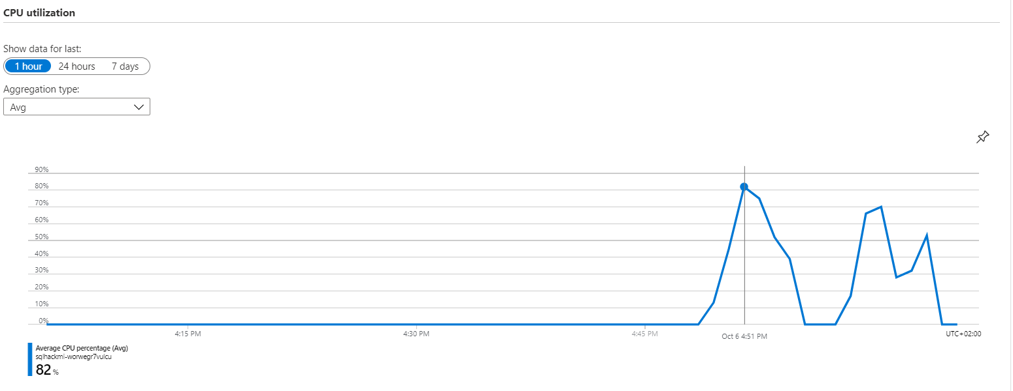

Instructions/Narrative | Screenshot | Notes
Click into the graph to go into Metrics chart screen. Here you have more flexibility over the data being reported and the format of the chart. Let’s add Storage Space Used the chart.  Click Add Metric  In the Metric drop down select Storage Space Used.  . | 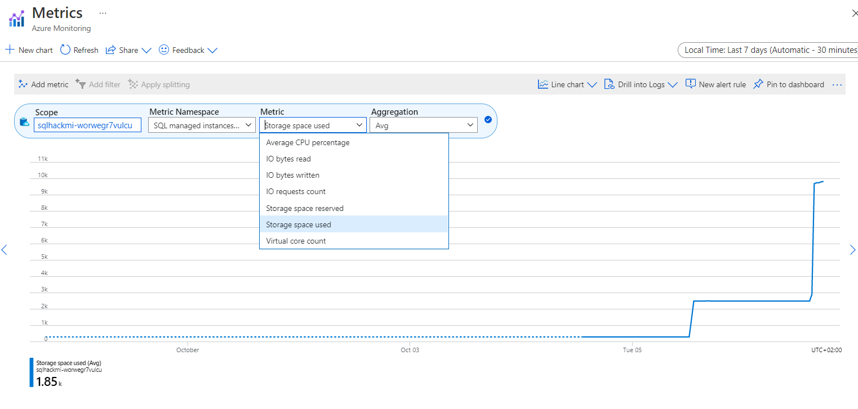 | Notice that from the chart screen you can alter the type of chart (Line, Area, Bar, Scatter to data Grid), set up alerts, and pin the chart to your Azure Portal dashboard.
Click Local Time on the top right of the chart to view the data for various time intervals. | 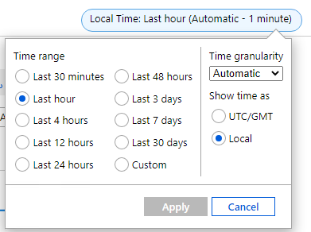

Using Log Analytics with KQL to visualize SQL MI and Database Stats

Now that we can use the global monitoring tool Log Analytics to identify which SQL Managed Instance .
Instructions/Narrative | Screenshot |  | Notes
On the Azure Portal, on the SQL Managed Instance Resource, click on Logs on the left Menu  You will find several query templates  You can test the CPU utilization threshold template  And modify the parameters if needed. | 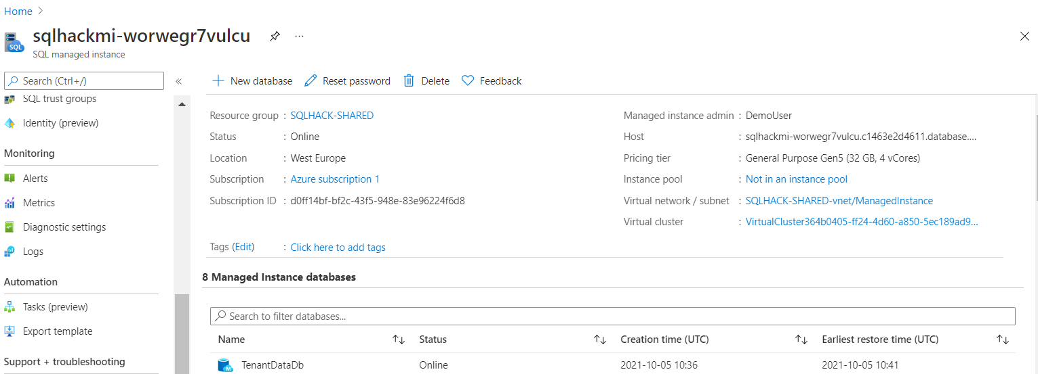
 | 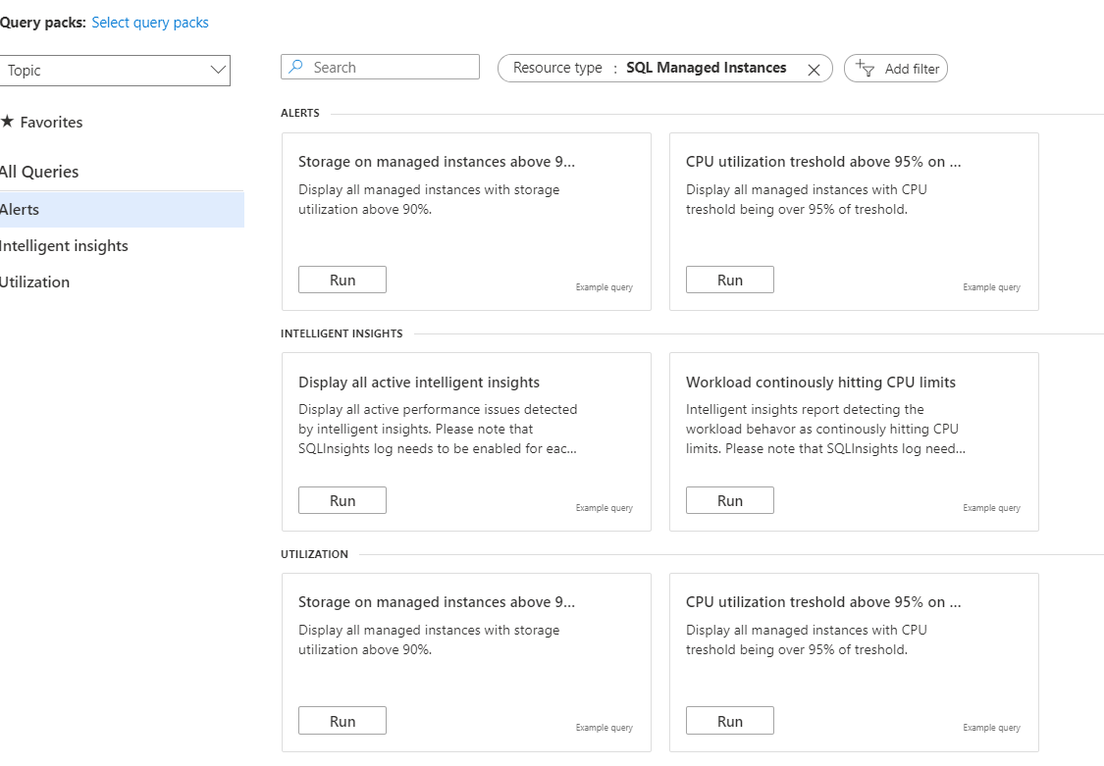
Instructions/Narrative |  | Screenshot |  | Notes
Create a new Query |  | 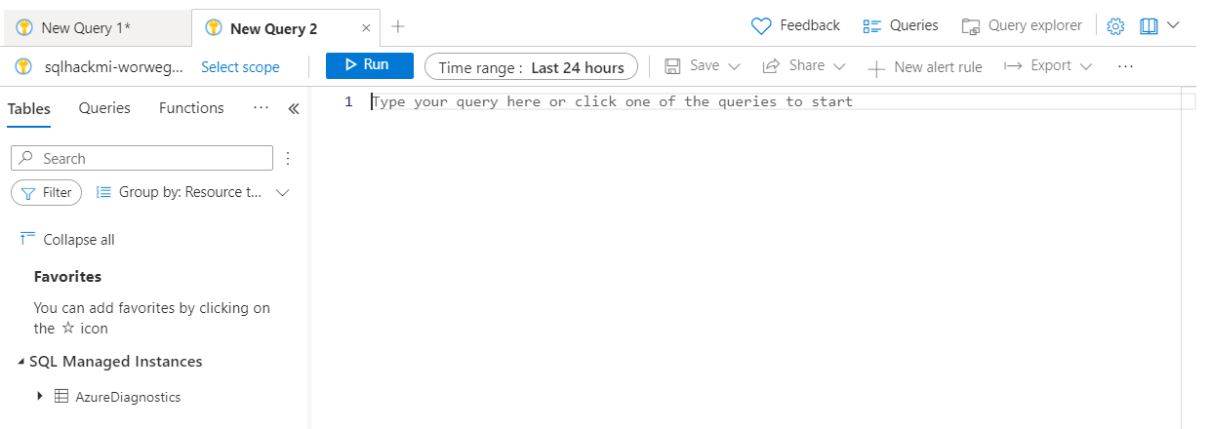
You can try the following queries.  AzureDiagnostics is the table receiving the different diagnostics  Modify the Time Range, By default 24hours  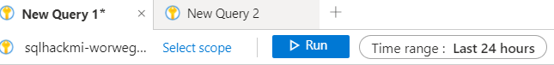 |  | //general queries  // query 1 without filter  AzureDiagnostics  // query 2 SQL MI Resource usage  AzureDiagnostics  | where Resource == "SQLHACKMI-WORWEGR7VULCU" //replace with your SQL MI Instance Name  | where Category == "ResourceUsageStats"  // query 3 on database: waits Stats  AzureDiagnostics  | where Resource == "TENANTCRM"  | where Category == "QueryStoreWaitStatistics"  // query 4 on database: errors  AzureDiagnostics  | where Resource == "TENANTCRM"  | where Category == "Errors" |  | Language Reference  SQL to Kusto query translation - Azure Data Explorer | Microsoft Docs
On the results for each of the queries, change the to Chart  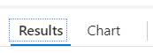  The chart Formatting is on the right. |  | // more specific queries  //Query get CPU usage  AzureDiagnostics  | where Resource == "SQLHACKMI-WORWEGR7VULCU" and TimeGenerated > ago(2h) //replace with your SQL MI Instance Name  | where Category == "ResourceUsageStats"  | project TimeGenerated, todecimal(avg_cpu_percent_s)  // visualize the resulset as a chart  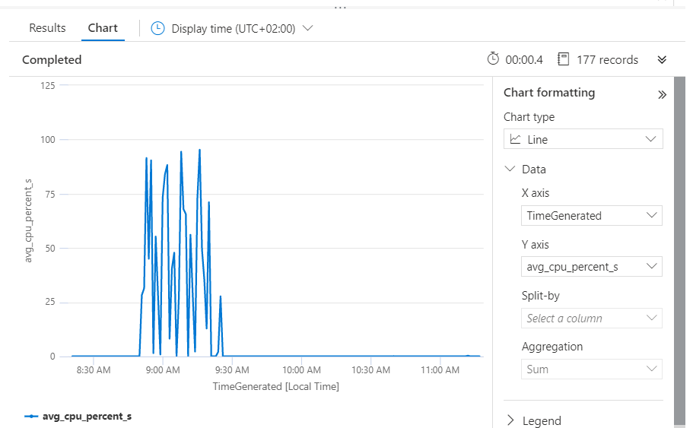  // Query get database Waits Stats  AzureDiagnostics  | where Category == "QueryStoreWaitStatistics"  | summarize Total_Wait_Ms = max(todouble(total_query_wait_time_ms_d)) by wait_category_s,DatabaseName_s  | order by Total_Wait_Ms desc  // visualize the resulset as a chart  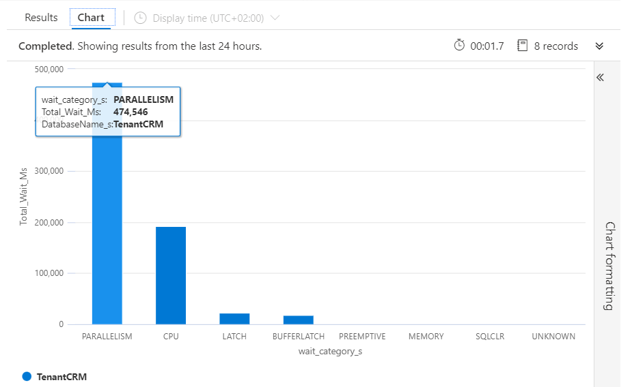

We’ve now seen how the various performance monitoring and diagnosis tools – the Azure Portal, DMVs and the Query Store reports all revealed that the CPU was under pressure. The DMVs and Query Store reports also allowed us to drill-down to root cause and identify the worst offending query. In the real world you would now progress to tune the offending query to reduce the overall load on the Managed Instances CPUs and thereby improve the databases and environment performance.

